## Problem 1 – BBC News

Create a Web page (HTML5 + CSS3 + images) that looks and behaves like the screenshots below:

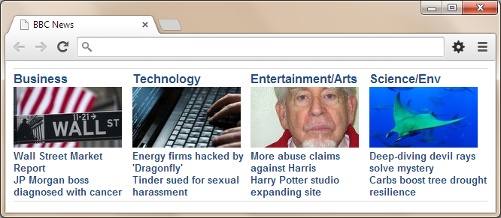

http://www.clipartbest.com/cliparts/4Tb/G59/4TbG59GTg.pnghttp://www.clipartbest.com/cliparts/4Tb/G59/4TbG59GTg.png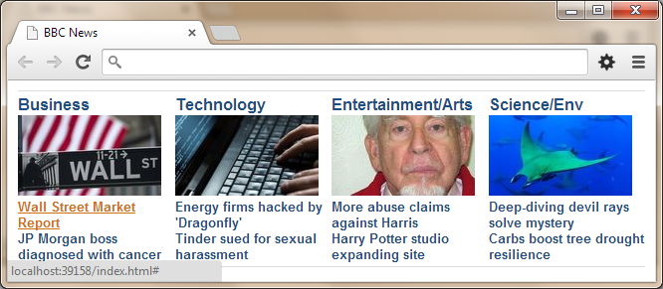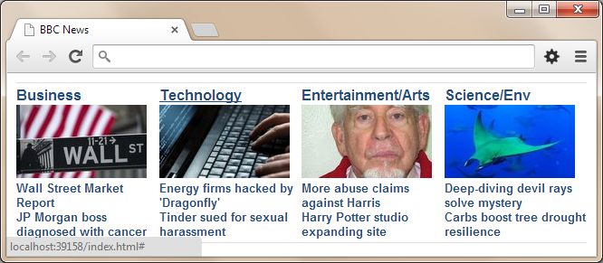

* The mouse hand-pointers and the bottom bar in the screenshots are not part of your page, so please skip them.

### **Input**

You are given the above screenshots + the images for the above three news items + the texts on the site.

### **Output**

The output should be valid HTML5 + CSS3 + images that implement the above Web page.

### **Constraints**

* Font: Arial / Verdana / sans-serif.
* Fixed width: 630px.
* The site should open correctly in Chrome 35.
* Responsive design is not required.
* Pixel-perfect implementation is not required.